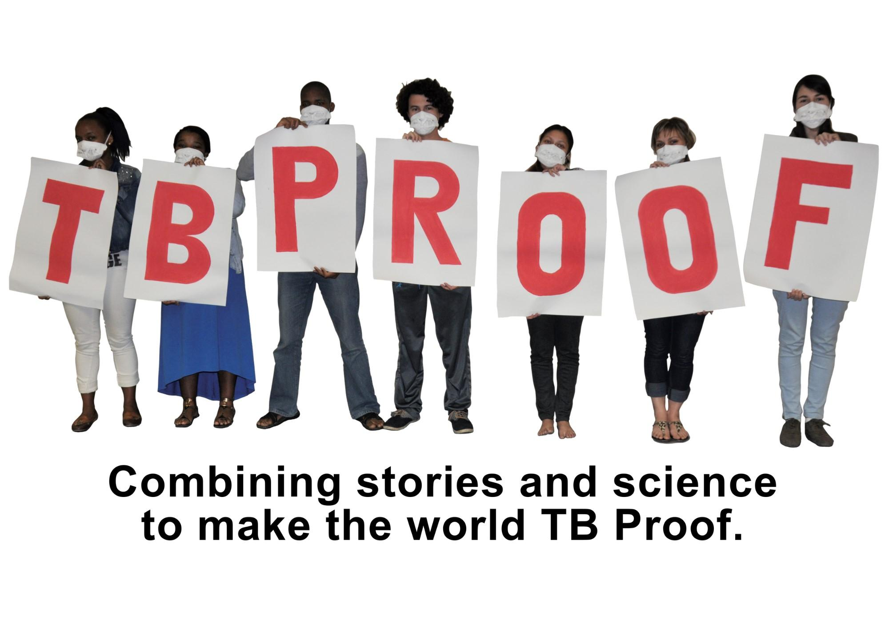

Tuberculosis Stigma Ibala le-TB
“Akukho mntu ufanelwe ukuphathwa kakubi ngenxa yesisigulo ngoba akukho mntu uzicelelayo ukuba ne TB. Umntu one TB ufanelwe kuphathwa ngendlela efanayo nabanye abantu. Sukubajongela phantsi abantu abane TB" (kutsho umntu wasifazana, eKhayelitsha).
September, 2024

Tuberculosis
01
Isifo sephepha (Tuberculosis) (TB) ngowona mba wezempilo wehlabathi jikelele , ochaphazela izigidi ngonyaka. Ngaphandle kophuculo kunyango lwe-TB nothintelo lwe-TB, ukubekwa ibala malunga ne-TB kuseyingxaki enkulu. Inokunqanda abantu ukuba bangayi emazikweni ezempilo ukuze kuqwasalela impilo zabo, ukwahlukana kubanye abantu, kwaye iyayonzakalisa nempilo ngokwase ngqondweni (harm mental health). Ukujongana ne-bala le-TB (TB stigma) kubalulekile kakhulu siqinisekisa ukuba sonke siyasebenzisana ukuba nelizwe elingena TB, siphinde siphucule nobomi babo bachaphazekileyo.

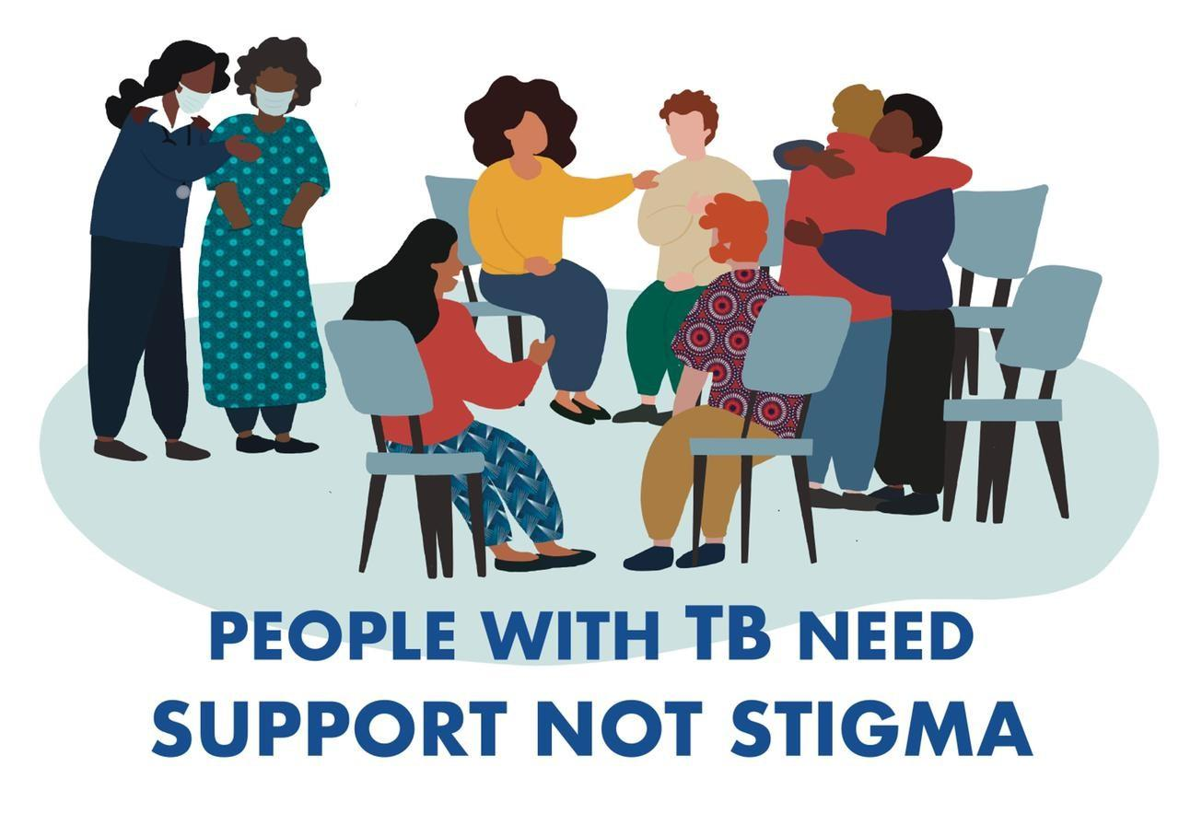

Abantu abane TB bafuna inkxaso HAYI ukubekwa ibala

Stigmatizing Language- Ulwimi Olubeka ibala

02
“Lithuba elide singazange siyithathele ngqalelo indlela esithethatha ngayo nge-TB, ngabantu abachatshazelwe yi TB naba gula yi TB, malunga neziphumo zendindi zonyango , nendlela zongenelelo ezahlukeneyo . Zange siyibeke icace kwa indlela esithetha ngayo ukuba inako ukubeka amabala nge TB, iyacalucalula, ayakhi, iyakhubekisa kwaye ikwahlukanisa nabantu” -kutsho u Dr. Lucica Ditiu Executive Director Stop TB Partnership
Musa  - Musa ukusebenzisa u-TB Contact  - Musa ukusebenzisa- u-Defaulter  - Musa ukusebenzisa u-TB Suspect  - Musa ukusebenzisa u-TB Control  - Musa ukusebenzisa u-AIDS Patient | Yenza  - Kungcono usebenzise u-Contact Person.  - Kungcono usebenzise u-Person lost to follow up.  - Kungcono usebenzise u-Person with Presumed TB.  - Kungcono usebenzise u-TB prevention and care or ending TB.  - Kungcono usebenzise a person living with HIV/AIDS/PLHIV.



Iindidi ze Stigma
03
Ukuzibeka ibala ngokwakho (internal stigma): Kuxelwa izimo zengqondo neenkolelo ezingalunganga abanokuthi abantu abane-TB babenazo malunga neziqu zabo. Oku kunokukhokhela kwindlela oziva ngayo, intloni oye ubenazo , ukuziva unesazela , kunye nokungazithembi, iye ichaphazele uxinzelelo lwengqondo (i-mental health) kunye nokuzimisela ukufuna ukunakalelwa empilweni.

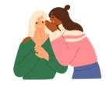
(Anticipated stigma): Kuxelwa uloyiko lokufumana ucalucalulo okanye indlela zokuzibonakalisa ezingalunganga ezibangelwa ngabanye abantu xa umntu ezixela i-status sakhe se-TB. Olu loyiko lunga nqanda umntu ekuthetheni nge TB, nasekukhangeleni uncedo lwezempilo, okanye ekugqibeni amachiza akhe we-TB.

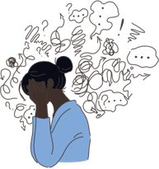
UKubekwa ibala (Enacted stigma) Oku kubandakanya amava okwenene ocalulo kunye nempatho embi evela kwabanye abantu xa umntu eveza i-status sakhe se-TB. Oku kuquka ukukhethelwa bucala ekuhlaleni, ukuthukwa, kunye nempatho engafanelekanga kwiindawo zokusebenza okanye kumacandelo wezempilo.

i-Influence ye-Stigma
04
Ukubekwa ibala nge TB liphenjelelwa zizinto ezininzi. Kukho iimbono ezahlukeneyo zesini – Uphando lubonisa ukuba amadoda anqabile ukuba afune uncedo nokhathalelo lwempilo (health care) kunabasetyhini. Iingxaki zasekuhlaleni kunye izithintelo eziqulathiweyo ezifana nokusetyenziswa kweziyobisi, uxinzelelo lwengqondo (mental health) ,kunye nokunqongophala kwezentlalo noqoqosho kungane galelo ekubekweni ibala(Stigma), oku kwenza kubenzima ukuba abantu bafumane ukhathalelo lwempilo (health care) abaludingayo. i-Covid-19 iye yenza ezingxaki zankulu kwakhona ngokujongela phantsi icandelo lwezempilo kune neengxaki zoluntu. Ukunyhashwa kwamalungelo oluntu, anjengo calucalulo nobundlobongela, lo nto yenza istigma (ibala) likhule libe luninzi. iNdlela zokuziphatha ezingekho semthethweni ezinje ngokusetyenziswa kweziyobisi nokuthengisa ngomzimba zinomthelela omkhulu eziwenzayo ekufikeleleni kwi TB treatment (NSP).

05 Amaqhinga okulwa ibala

Ukwandisa ulwazi malunga namalungelo abantu kunye nefuthe lebala (stigma) kunye nolocalucalulo, kuyakugxilwa ukwandisa iinzame ezikhokelwa luluntu ukunciphisa ibala (istigma). Oku kubandakanya intsebenziswano nemibutho yasekuhlaleni enempumelelo kunye nokuxhasa amanyathelo akhokhelwa ngabalingane abakhawulelana nokulwa ibala (stigma). Kubalulekile ukuxhasa iinkonzo ezibandakanya wonke umntu, nezingenacalucalulo, ukuqinisekisa ukuba abantu bayafikelela kwiinkonzo ezisekelwe kuluntu ezikumgangatho ophezulu, ezinentlonipho. (WC NSP draft)
Ukulwa ngokufanelekileyo ukubekwa ibala (stigma) nocalucalulo, iinzame kufuneka zigxininise ekwandiseni ulwazi ngeengxoxo zoluntu malunga nezizathu neempembelelo zokubekwa ibala (stigma), kunye nokukhuthaza uhlolo olukhawulezayo ukukhokela izicwangciso zokunciphisa. Kufuneka sixhase kwaye someleze iinzame ezisekelwe kuluntu kwaye sisebenzise izixhobo ezifana ne-peer-led (i-TB Champions) amaqela e-WhatsApp ukudibanisa abantu ngeenkonzo.
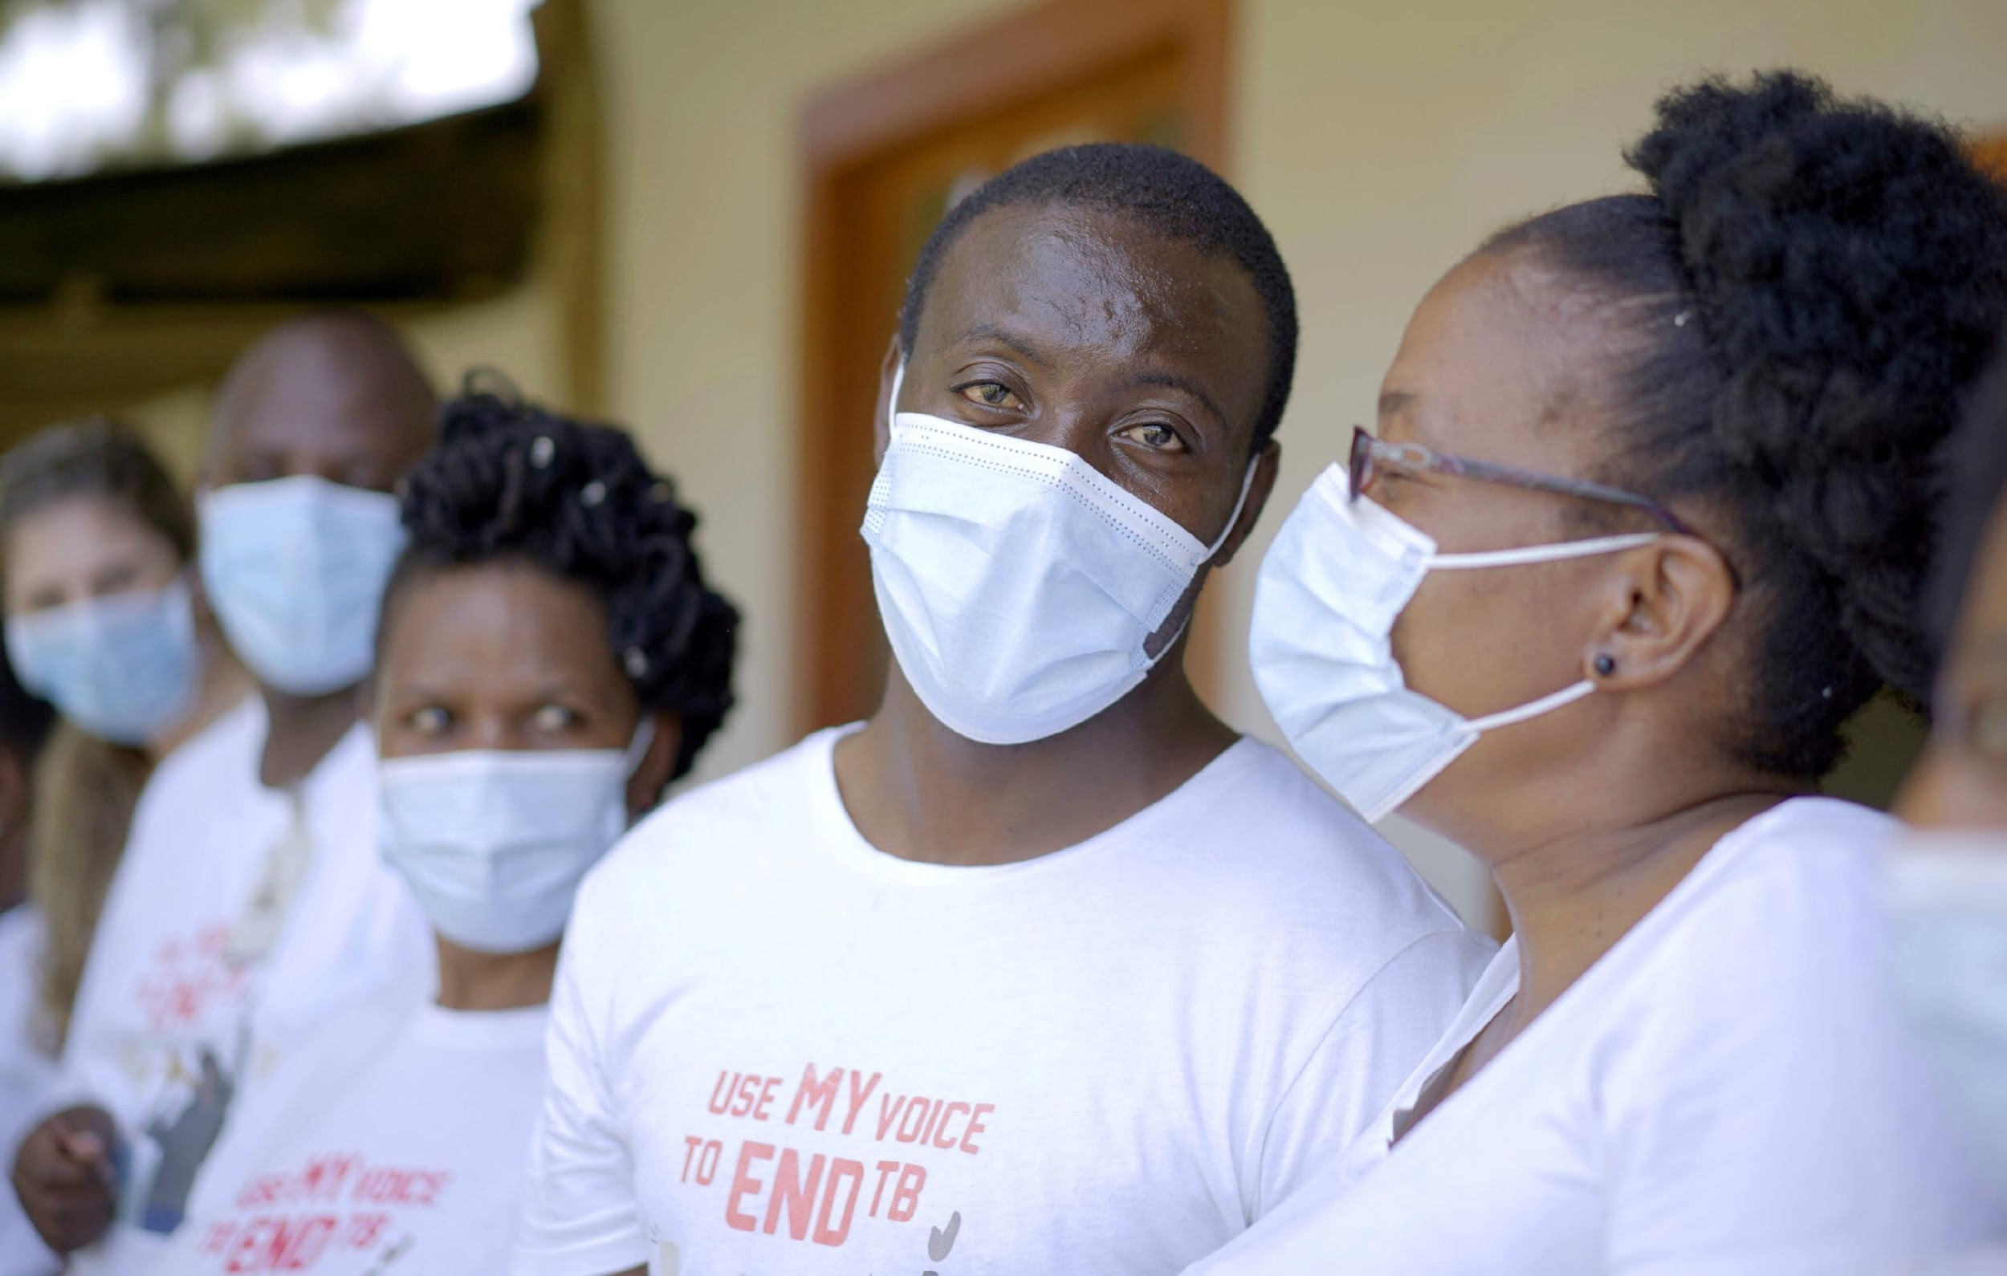
Ukukhuthaza ukusetyenziswa kweefowuni zoncedo kwimiba efana ne-HIV / AIDS, ubundlobongela obusekelwe kwisini (GBV), kunye nempilo ngokwasengqondweni (mental health), kunye nokwandisa ukufikelela kwiingcebiso zomthetho zokuphulwa kwamalungelo, ngakumbi kubantu abasengozini, nawo ngamanyathelo abalulekileyo.

Conclusion
Isifo sephepha (TB) ngowona mba wezempilo wehlabathi jikelele , ochaphazela izigidi ngonyaka. Ngaphandle kophuculo kunyango lwe-TB nothintelo lwe-TB, ukubekwa ibala (stigma) malunga ne-TB kuseyingxaki enkulu. Ibala (TB Stigma) lithintela abantu ekufuneni ukhathalelo lwempilo, nto leyo ekhokelela ekulibazisekeni ukuxilongwa kunye nonyango. Ukujongana nebala le-TB kubalulekile ekuphuculeni ukhathalelo lwe-TB kunye nokuphucula ubomi babantu abaphila ne-TB.

